**Overview:**

The Oliver’s App project details the development, deployment, and managing of Oliver’s App – A really cool smartphone app made for entertaining and wholesome conversation. The project aims to create the app, refine it and release it to the public. Our goal is to have 1,000 users and overwhelmingly positive reviews. Our vision is to help create good memories through the use of our app as human connection is incredibly valuable.

**Goals and Objectives:**

Our main objectives are listed as follows, in sequential order:

1. Creation of the company ethos
2. Completion of a company resource master list
3. Completion of the company final business plan
4. Celebration of the app trial run
5. Celebration of the app beta-testing phase
6. Celebration of the official company soft launch
7. Official app release
8. 1,000+ Active Users with a positive rating

**Scope:**

Our aim is to create a smartphone app for android and iOS devices for English language users. Upon reaching 1,000 active users with positive ratings, more languages may be added to the app. Our app will have messaging features and the ability to share media from the mainstream outlets like YouTube and also create groups for group messaging. The app not will be formatted for any other devices.

**Stakeholders:**

The stakeholders are as follows:

1. The Founder
   * Oliver Warlick
2. The Operations team
   * Engineers and all development specialists
3. The QA Team
4. The Internal Testing Team
5. The External Testing Team
6. The Active Userbase

**Timeline and Schedule:**

The timeline for our project is broken down into 8 different phases and designed to take place over the course of about a year, listed as follows:

1. Creation of the company ethos
   1. June 8th 2025
      1. Define the company mission, plan, niche, etc
      2. Stakeholders: The Founders
2. Completion of a company resource master list
   1. June 30th 2025
      1. Define the resources necessary to function and thrive as a business are and identify a procurement strategy with a cost analysis
      2. Stakeholders: The Founders and the Operations team
3. Completion of the company final business plan and the start of app development
   1. July 20th 2025
      1. Define the business goals in the short, medium, and long term
      2. Stakeholders: The Founders and the Operations Team
4. Celebration of the app trial run
   1. October 15, 2025
      1. Launch the MVP (minimum viable product) to testing team
      2. Stakeholders: Operations team and the internal QA/testing team
5. Celebration of the app beta-testing phase
   1. January 30th 2026
      1. Launch of the product for beta-testers, following the changes made after the launch of the MVP.
      2. Stakeholders: QA/testing team
6. Celebration of the official company soft launch
   1. April 30th 2026
      1. Launch of the product for the early access community as well as testers
      2. Stakeholders: Operations team and the QA/testing team and external testers
7. Official app release
   1. July 15 2026
      1. The app is released to the public and the operations team is ready to respond to user feedback
      2. Stakeholders: The Founders and the Operations team
8. 1,000+ Active Users with a positive rating
   1. December 30 2026

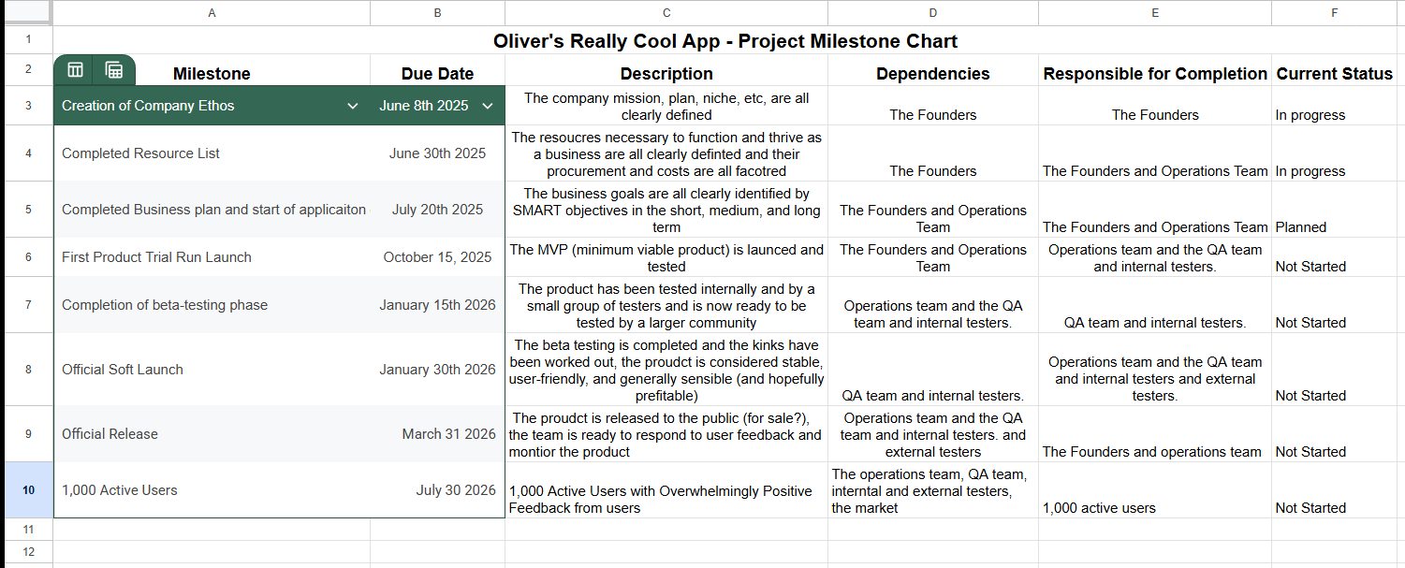

**Resource Plan:**

1. Cloud computing service
2. Code repository
3. Computers for app development and communication
4. Project Management Software
5. Android and iOS devices for testing
6. Money for promotion ($50)
7. Development team (1 paid person + open source help)
8. QA team (1 paid person + open source help)
9. External testers
10. Users

**Potential Risks:**

Some of the project risks include not completing the tasks in time for the official soft launch and not meeting the release date. There is also the risk of miscalculating the amount of resources it will take to complete the app with regard to manpower and computing resources. There is also a risk of a competitor stealing our ideas if we decide to go open source. We will meet 2 times a week to ensure our work is being done on time and use email and a project management software board to stay on track.

**Success Metrics:**

Our project is successful once we have a bug-free, user-friendly app which is loved by our userbase and beneficial to their lives. Reaching 1,000 active users will serve as a huge milestone that we are succeeding in our efforts.